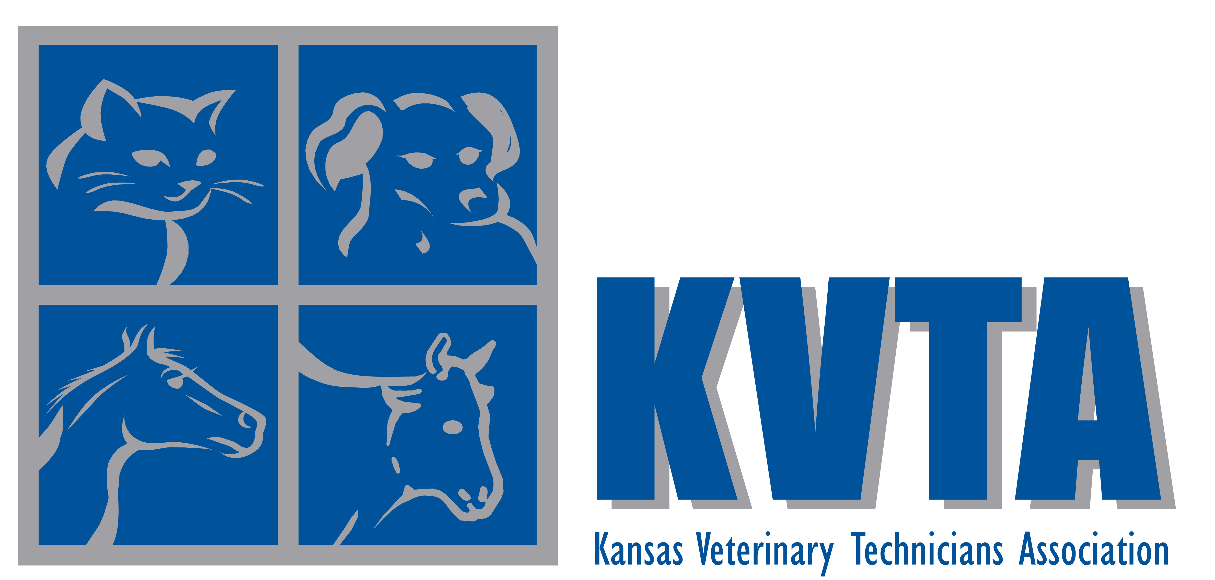

Newsletter
Volume No. VI Issue No. 1 Spring 2010

Executive Board

President
Kara M. Burns, MS, MEd, LVT
28276 Homestead Road
Wamego, KS 66547
(785) 765-3705
kara_burns@hillspet.com

President – Elect
Amber Nuttycomb, RVT
28251 Road T
Logan, KS 67646
(785) 689-4853
a_houser86@hotmail.com

2-Year Member at Large
Mary Berg, RVT
1002 E. 850th Road
Lawrence, KS 66047
(785) 748-0926
mlberg1@al.com

1-Year Member at Large
Bridget M. Keesling, RVT, BA
3287 US 59 Hwy
Perry, KS 66073
(785) 597-2383
bridget_keesling@hillspet.com

NAVTA Liaison
Jamie Kirkham, RVT
13294 Decatur Rd.
Valley Falls, KS 66088
(785) 945-3917
jamie_kirkham@hillspet.com

Secretary/Treasurer
Cheryl Hermann, BA, RVT
22637 NW 2150 Rd.
Garnett, KS 66032
(785) 448-3709
cahvettech@yahoo.com

Representative to the Registration Board
Vickie Ograin, RVT
2502 SW Berkshire Dr.
Topeka, KS 66614
(785) 478-3135
vograin@aol.com



Our Mission
The mission of the Kansas Veterinary Technicians Association is to represent, promote, and advance the veterinary technology profession and enhance animal health and welfare within the state of Kansas and throughout the nation. It is through education, public awareness, membership development, and legislative initiative, and by working together with the KVMA and allied
professions that KVTA will achieve its mission.

President’s Message

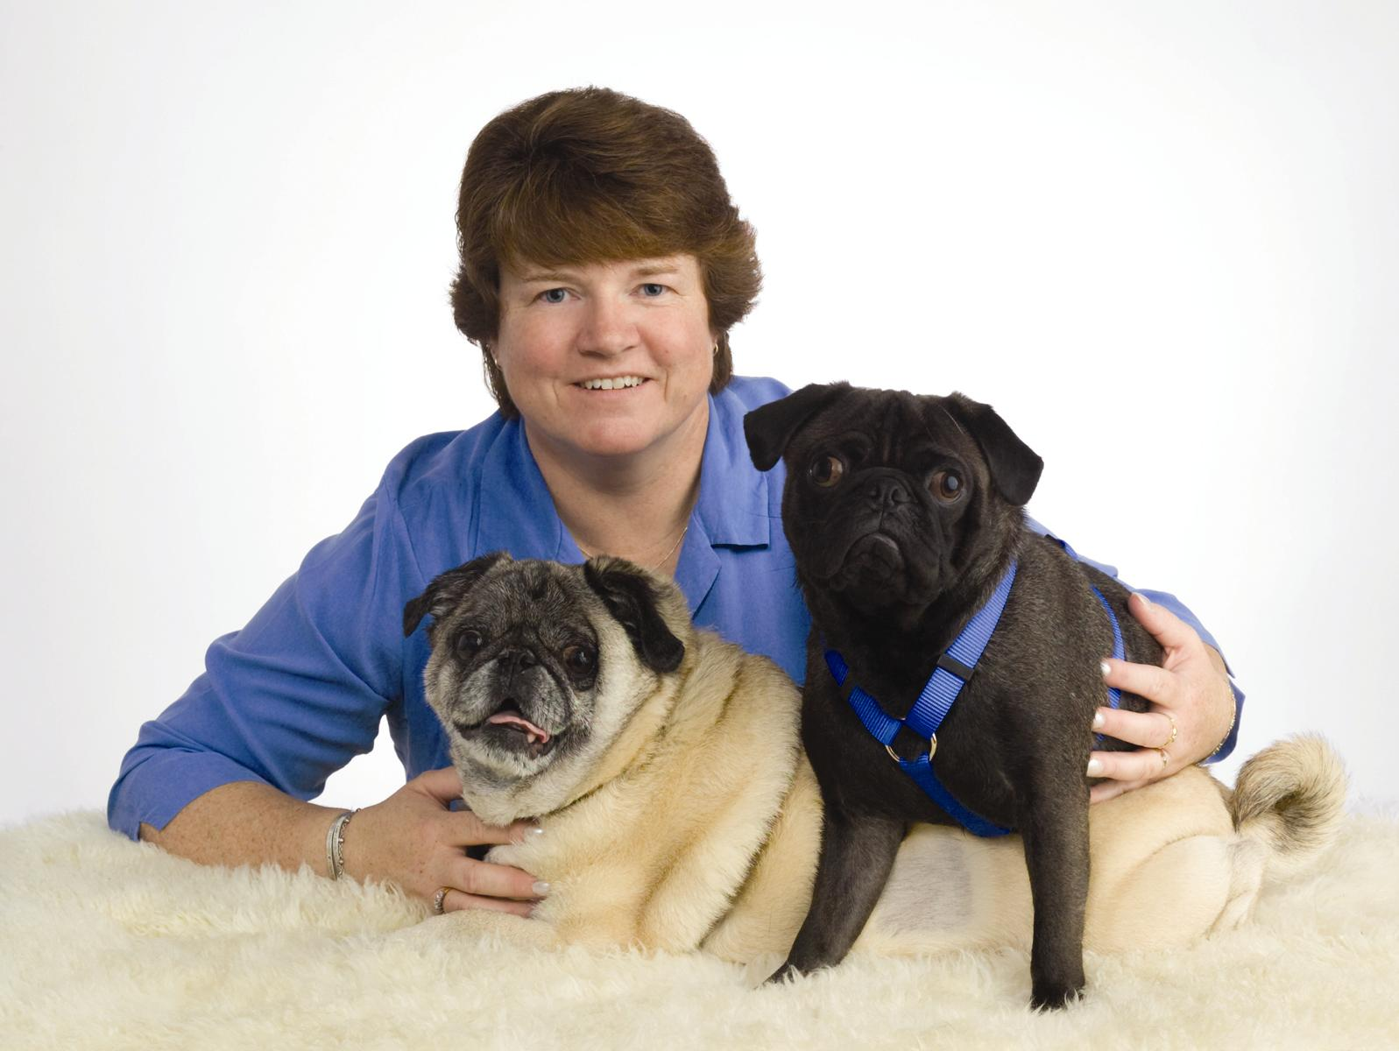

Kara Burns, MS, MEd, LVT

Welcome to Spring!

I want to welcome the new KVTA Executive Board and thank them for volunteering to help move KVTA forward. I also want to thank the departing members of the 2009 Board for volunteering their time to make the KVTA and the technology profession the best it could be!
The KVTA Board has a great deal of energy and enthusiasm and some wonderful new ideas! We cannot do this alone however, so I ask that each of you continue to visit the KVTA site (www.kvta.net) and if you are not already, become a KVTA member. Visit our Facebook page to stay up to date with the latest happenings in Kansas.
Technicians are crucial to the veterinary healthcare team and you should be proud of the hard work and dedication you provide. As a profession we need to stay up to date with the latest developments in our state and across the nation. We also need to be on top of the latest innovations and research so we can continue to help our clients and most importantly, our patients.
The only way we can fail is to do nothing. Working together will bring about change and accomplishments for the KVTA. Our first meeting in Manhattan was very successful. The Board listened to suggestions from technicians across the state and will begin to implement some of the suggestions in 2010. We are small, but we are growing!
We want to know what you want from the KVTA. We also want to know what is going on in your clinics, your local area, or anything that you feel you would like to share. If you have a tip that you think would aid a colleague – send it in. We will get it in the newsletter or post it on the website.
Get involved – let us know your vision for our state association and the profession. I encourage you to reach out to us and let us know how KVTA can help make this happen. Remember, the only way we can fail is to do nothing.

Continuing Education

April
American Board of Veterinary Practitioners Symposium
April 15 - 18, 2010
Denver, CO
www.abvp.com

Central Veterinary Conference East
April 9 – 12, 2010
Baltimore, MD
www.cvceast.com

North American Veterinary Dermatology Forum
April 14 – 17, 2010
Portland, OR
www navdf.org

Kansas State University
April 21-22, 2010
Rabies Immunology Workshop
www.k-state.edu/CE/index.htm

Kansas State University
April 25, 2010
Frank W Jordan Seminar
www.k-state.edu/CE/index.htm

May
Veterinary Specialty & Emergency Center
May 13, 2010
Environmental Hyperthermia
Overland Park, KS
vseckc.com

June
Kansas State University
June 6-9, 2010
72nd Annual Conference for Veterinarians and KVMA Trade Show
www.k-state.edu/CE/index.htm

American College of Veterinary Internal Medicine
June 9 – 12, 2010
Anaheim, CA
www.acvim.org

Kansas State University
June 17-18, 2010
www.k-state.edu/CE/index.htm

North Central Conference of Veterinary Laboratory Diagnosticians
www.k-state.edu/CE/index.htm

Nebraska Veterinary Medical Association
June 17 – 19, 2010
NVMA Summer Meeting
Columbus, NE
www.nvma.org

July
Veterinary Specialty & Emergency Center
July 8th, 2010
Parvo 2 C – The “New” Parvo
vseckc.com

Kansas State University
July 31 – August 3, 2010
24th Meeting of the American Society of Rickettsiology
www.k-state.edu/CE/index.htm

Pacific Veterinary Conference
July 31 – August 4, 2010
San Francisco, CA
www.pacvet.net

AVMA Conference
July 31 – August 4, 2010
Atlanta, GA
www.avmaconvention.org

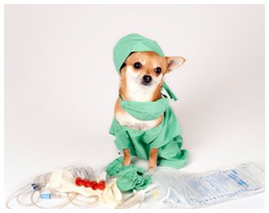

MWCC Update

Chris Morrow, DVM
Veterinary Technology Coordinator

Maple Woods would like to congratulate the students who competed in the first annual Missouri Veterinary Technology Student Academia Bowl. The Academia Bowl took place during the Missouri Veterinary Medical Association Conference in St. Charles, MO. The Maple Woods students completed against four other veterinary technology programs to win the traveling trophy.

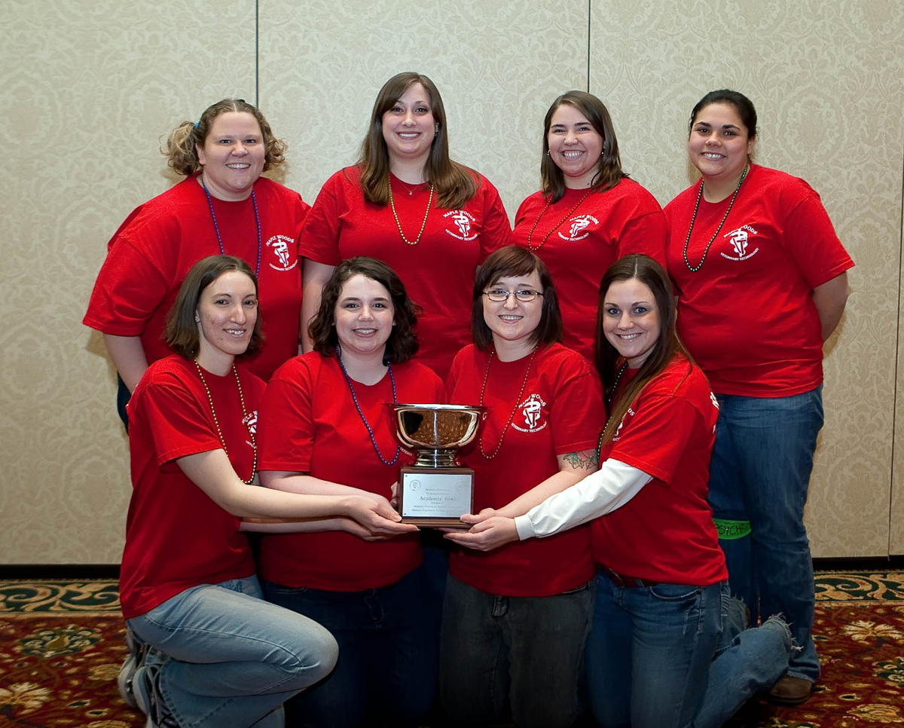
Left to Right
Front Row: Angela Weber, Shannon Quinn, Meagan Hake, and Logan Hudlemeyer
Back Row: Amy Dawson, Sarah Moore, Katie Frerking and Allie Ruiz

Maple Woods students will be getting more animal exposure this year. To increase student knowledge of different species, the Maple Woods program will be adding snakes, bearded dragons, and hedgehogs to the species covered during the Lab Animal Medicine course. Students in the program also get to work with dogs cats, horses, cattle, sheep, goats, pigs, mice, rats, guinea pigs, rabbits, and birds. We constantly look for ways to increase student exposure to the animals they may experience in practice.
The annual Powder Puff football game drew a crowd of close to 200 students, alumni, and family members. Even though the action was rough, no major injuries occurred during the game. This year the first year students defeated the second year students by one touchdown.

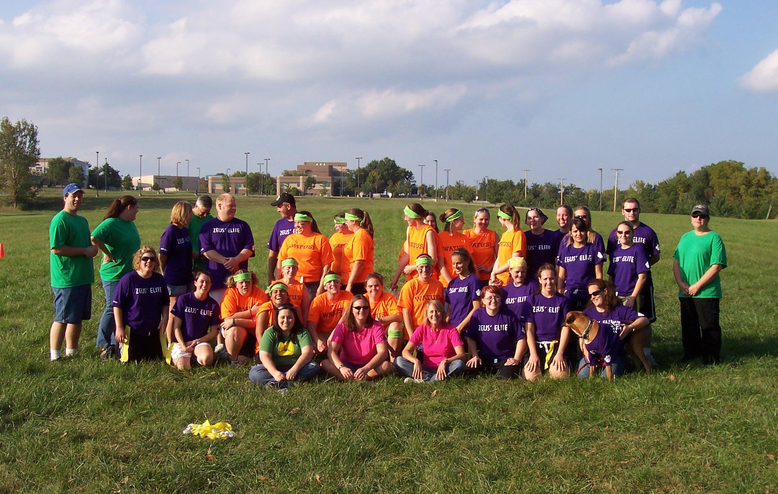
Powder Puff Football Game

The annual volleyball game was held on Sunday March 21st at 6 pm. Both first and second year students had two teams that competed for the trophy and bragging rights.
The Maple Woods Oath and Pinning Ceremony will be held May 5th, 2010 at 7 pm in the Arbor Room located in the campus student center. The graduating class will take their veterinary technicians oath and receive their pin. Alumni are encouraged to attend and they may receive a pin as well. Refreshments will be served. Family, friends, and co-workers are all invited.

HOME DENTAL CARE
AND CLIENT COMMUNICATION

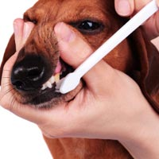

Mary L. Berg, BS, RLATG, RVT, VTS (Dentistry)
Gentle Care Animal Hospital

Oral disease is one of the most prevalent diseases in dogs and cats. 80% of adult dogs and 70% of adult cats have some form of oral disease. Dental problems are among the top three pet owner concerns in dogs and cats. Calculus and gingivitis are the most common conditions diagnosed by veterinarians in all ages of animals.
Why is the incidence of dental disease so high? Is it due to lack of compliance or the lack of education given to the client about the importance of dentistry? Pet’s living longer lives, could be one reason that oral disease is more prevalent. We are already improving many aspects of their lives, but dental care seems to still lag behind.
Companion animals are an important part of our lives. Many people consider their pet a part of their family. This bond has been important to the veterinarian and his staff because clients are increasingly interested in seeking improved care for their pets. It is essential that communication remains open between all parties. All members of the veterinary team must be excited and motivated, projecting that enthusiasm to the client. The veterinarian and his staff must educate the client about the need for dentistry and convince them of its importance. Statistics show that 25 percent of your clients will accept whatever you say immediately. Another 60 percent will take a little time to accept your recommendations, while the remaining 15 percent will not accept your suggestions at all.
It is necessary to communicate the importance of dental treatment and oral care in many ways. It should become as routine as vaccinations and heartworm testing in your clinics.
Educate
As veterinary health professionals, it is our job not only to promote dentistry but also to educate our clients about the importance of good oral health. How can we do this? Advertise, dental report cards, giving out toothbrushes and sample packets are a few ways to promote the services you offer. The technician is responsible for initiating client education. Start this education process with your clients at the first puppy or kitten visit. Talk with them about the importance of good oral care by expressing the fact that the mouth is a mirror to the body. Give handouts explaining the relationship between oral disease and systemic health. Pictures are worth a thousand words. Use pictures to give the client an impression of what can happen if oral home care is not given to their pet!
The use of a dental report card is a great way to help the client understand the treatment given to their animal. Include a simplified dental chart in which problem areas can be marked or highlighted. A section for diagnosis, treatment, home care, prescriptions and follow-up visits should be included on this report card. Keep it simple and use bright, cheerful colors with before and after pictures in the take home sheet.
Client Communication
Some clients may be reluctant to have routine dental cleanings done because they fear anesthesia. A handout concerning the safety of anesthesia, preanesthetic testing and safeguards taken will be helpful to alleviate those fears. Also let the client know what is included in your routine prophylaxis procedure. They will become more comfortable knowing exactly what will happen to their pet while it’s under your care. A simple flyer that briefly explains each step taken can be comforting to the client.
There are many forms to include dental fee forms, estimates, anesthesia release forms, and take home care forms. Using the forms not only help to inform the clients of procedures but protect your practice should a problem arise. Dental fee forms and estimates should emphasize that it is only an estimate. Explain that your clinic strives to give the best possible care for the client’s pet. In order to do so, the anesthetic or procedure time may vary. Sometimes tests or procedures must be done that were not anticipated when giving this estimate. The clinic will do the very best to inform the client of any tests or procedures that must be done which might cause an increase in the estimate. Our job is to give the pet the best possible medical and surgical care at a reasonable cost. Let the client know that payment is due at time of service. If payment can’t be made in full at time of service, prior arrangement for payment must be made in advance.
Release forms should include the risks involved with general anesthesia and explain the need for pre-anesthetic screening tests. The authorization to treat also states that the undersigned certifies that he/she is the owner of and is the responsible person for the animal described above. It’s a good idea to include an abandonment clause stating that if the owner does not return to claim the animal within a specified time period, the animal will be turned over to a local shelter. Be sure to get contact phone numbers where the client can be reached throughout the day. Some clinics have a clinic cell phone or pager that can be given to the client if they do not have a phone.
The proper use of dental charts and record keeping is a critical part of proper dental care. There are several types of charts available. A modified version of the dental chart can be used as a take home care sheet for the client that will help them understand the problem areas and home care recommended for their pet. This form should also give a contact number for questions or concerns and the date of the follow-up visit.
A reminder letter can be a courteous way to impress upon the client the need for follow up visits. This can be sent after treatment or surgical procedures related to periodontal disease or post surgical that explains the need for a follow-up visit. The need to evaluate healing and to evaluate home care effectiveness to ensure the continued prevention of disease progression. Ask the client to call the office to schedule a follow up exam. Many clinics include the cost of the follow up visit in the initial service fees unless additional sedation or anesthesia is required.
Evaluate
Before you prescribe home care for a patient, it is important to assess the client and the animal. Is the owner ready, willing and able to perform proper home care? Are they committed, interested and physically able to provide care? Does the pet have the temperament to allow for home care? All of these aspects must be considered before prescribing any home care regime. It will not work to prescribe routine brushing if you know the client will not follow through. If this is the case, you may be better off recommending an oral care diet as opposed to brushing.
Another issue which sould be considered when recommending home care is the degree of treatment necessary. For young pets, the prevention of plaque accumulation can be achieved by plaque removal at least two times per week. For moderate accumulations and disease following a professional dental prophylaxis plaque removal every other day can help improve oral health. When the degree of disease is severe, professional periodontal prophylaxis is necessary followed by twice a day chlorhexidine rinses for seven days and then once a week chlorhexidine rinses and daily brushing.
Demonstrate
Demonstrate oral cleansing techniques to the client. Telling a client to brush their pet’s teeth without a demonstration is of no benefit. When demonstrating, use a soft bristled brush or gauze. Use a 45 degree angle to the tooth and circular motion. It is important to start the demonstration with a dental model. This allows the client to see the actual brushing technique without the lips getting in the way. The model also shows them what all of the teeth look like and where problem areas might be lurking. Following the model, demonstrate on the owner’s pet or a clinic pet. Demonstrate on one side and observe the client brushing the other side. By doing this, you are able to evaluate their techniques and offer suggestions and tips. If you use the owner’s pet, you are also able to access the pet’s temperament and acceptance of tooth brushing.
A disclosing solution can be used to help demonstrate plaque on the teeth. This product comes in individual tubes with an applicator swab that allows the plaque on tooth to be disclosed without staining the fur.
Not every client or patient is a candidate for tooth brushing. There are alternative methods of plaque control and removal. Work with your clients to determine which would be the best option for them and their pet.
Advise and Recommend
It is necessary to warn the client that an animals failure to improve with tooth brushing may be due to an underlying disease such as; diabetes, kidney disease, FIV or leukemia. As veterinary professionals it is our duty to also warn the client about label claims. Not all products that say “veterinarian recommended” are good for their pets. Always recommend products with solid research to back those claims. Ask for research results to prove the product will be efficacious.
In 1997 a group of Veterinary Dental Health specialists formed a group called the “Veterinary Oral Health Council (VOHC)”. This council rewards products that claim to provide some type of oral benefit with a seal of approval. This seal of approval was based on the American Dental Seal of Approval currently use for human products. At this time, 22 products have been awarded this seal.
These are the products that currently have the VOHC seal of approval.

Prescription Diet® Canine t/d – Original and Small Bites

Prescription Diet® Feline t/d

Friskies® Feline Dental Diet
New and Improved

Prescription Diet® Feline t/d

Del Monte Tartar Check® Dog Biscuit: Small and Large Size

Friskies® Cheweez® Beefhide Treats

Science Diet® Oral Care Diet for Dogs

Science Diet® Oral Care Diet for Cats

Iams® Chunk Dental Defense Diet for Dogs

Eukanuba® Adult Maintenance Diet for Dogs

Greenies® Edible Dog Treats: Teenie, Petite, Regular, Large, Jumbo &
Light

Hartz Flavor Infused Oral Chews: Large and Small

Nestle Purina PetCare PVD (Dental Health) Feline

Nestle Purina PetCare PVD (Dental Health) Canine – Small Bites & Regular

Vetradent Dog Chews –(dc Dental Chews or Bluechews)

Vetradent Dog Chews – (Tiny Toy Dental Chews or Baby Bluechews)

Tartar Shield Soft Raw Hide Chews for Dogs

Bright Bites and Checkups Chews for Dogs – all sizes

The companies that have applied for this seal have tested their products using very strict protocols developed by the VOHC. Products that have this seal have good science behind them and have proven that they work. Additional information can be found at www.vohc.org. Look for it!!!!
Remember it is our responsibility to evaluate, educate, demonstrate, recommend and advise our clients considering oral home care.

References available upon request.
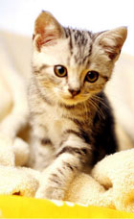

NAVTA Update

Liza W. Rudolph, LVT, CVT

Recently the Committee on Veterinary Technician Specialties (CVTS), a subcommittee of the National Association of Veterinary Technicians in America (NAVTA), granted the Academy of Veterinary Technicians in Clinical Practice (AVTCP) provisional recognition as a Veterinary Technician Specialty (VTS).
AVTCP is the ninth officially recognized veterinary technician specialty and is modeled after the American Veterinary Medical Association accredited veterinary college, the American Board of Veterinary Practitioners (ABVP). Following the ABVP model, AVTCP has developed three initial species-specific categories, Canine/Feline, Avian/Exotic, and Production Animal.
The credentialed veterinary technicians of the AVTCP are dedicated to providing superior, comprehensive, multi-disciplinary care to our clients and patients. Candidates are expected to be knowledgeable and demonstrate expertise in a broad range of clinical disciplines within their species specialty.
Candidates eligible for admission to the AVTCP examinations will be evaluated on multi-disciplinary aspects of clinical practice including: anesthesia/analgesia, behavior, dentistry, diagnostic imaging, general medicine (knowledge of systems and common diseases), general nursing, laboratory testing, pharmacology, practice management, and surgical nursing.
Veterinary Technicians interested in learning more about VTS certification in Clinical Practice should contact the Academy Chair, Liza Wysong Rudolph, LVT, CVT, at lwrlvt@aol.com

Do you play fetch?

Amber Nuttycomb, RVT

How many of you still take your dog's favorite toy and throw it across the yard to play fetch? A simple game can get you outside to spend time with Fido. Many animals are turned over to their local shelter just because the children of the family have out grown the puppy and have turned to video games instead. At Christmas time or birthdays many people choose a puppy, thinking it is an ideal present for the family. Yet when that puppy has grown up and is no longer cute, problems arise. The overgrown puppy, now a teenager is chewing up everything in sight! If bad habits don' t get corrected, Fido is soon turned out into the yard and is no longer an inside dog. He is then forgotten by the family and eventually is turned over to the local shelter or to another friend. Then the cycle continues, because the dog's bad habits were never corrected and he was never taught to be obedient. Lack of training and the disinterest of the animal's human family is the number one reason why animals are handed over to the shelter. Approximately 5 to 7 million companion animals enter animal shelters nationwide every year. Sixty percent of the dogs that walk through the shelter door are euthanized.
How can this ongoing problem be stopped? Start with teaching your dog to fetch. Take your dog on daily walks. Many dogs just enjoy a ride in the car or a run at the local park. A Frisbee or tennis ball is the perfect item to get your pup to play fetch. Fido's favorite toy will work just as well, as long as it is not too heavy, in case you accidentally hit him with it. Having your kids join in, might get them away from the computer or video game. Fido can also be a very good in helping you slim down. Long walks or jogs are just what a dog needs to run off steam and it will benefit you too! The second step would be to teach your dog obedience. Some basic commands are; sit, stay, come, lay down, and down. The problem with teaching dog obedience is that many people continuously repeat the same command over and over. The dog learns to ignore you, because there is no reprimand if he doesn't do what he is asked. The owner is the one looking dumb. Also Fido might have more than one trainer. It can make it very confusing to him who he should listen to. Another big mistake owners make is that when they give a command, he should correct the animal the first time a problem occurs, instead of repeating the command continuously.
At our practice we hold a bi-annual obedience/agility course. This enables our clients to see us out of the practice and has helped many of our clients spend valuable time with their dog. They to get to practice the many skills needed for their dog to mind correctly. Don't be afraid that your vet will say no. I asked my veterinarian about doing a weight loss program for our patients, and this is our third year running. We initially introduced to our community for free. We then added a price of 35 dollars to the class because we added more equipment. As the classes got bigger, expectations grew as well. We charged for our time and supplies. With the additional fees, surprisingly more pets came! It gave the clinic more publicity showing a friendly side and made us a little cash too.

KVTA Executive Board Meeting

March 6, 2010
KSUCVM
Veterinary Technician Conference

Kara Burns, KVTA President called the meeting to order at 5:05 pm. Board members present were: Kara Burns, Amber Nuttycomb, Vicky Ograin, Mary Berg, and Cheryl Hermann.
Old Business:
- Kara Burns is working with an attorney to apply for a 501(c)3, which will establish KVTA as a non-profit organization.
- KVTA is working on revamping our constitution. KVTA is still consulting with the Colorado and Minnesota Veterinary Technicians Associations regarding their constitutions.
- KVTA is now on Facebook.
- The board is still working on ways to improve the KVTA website.
New Business:
- Kara Burns and Amber Nuttycomb will be in contact with the KVMA in an effort to improve the relationship between KVTA and KVMA. In the future, it is hoped that the two organizations can work together to improve the Kansas Veterinary Practice Act, thus improving the quality of care offered by the veterinary healthcare team.
- KVTA will be working to improve our page on Facebook. We will be including a link to the KVTA website, a KVTA application, and also survey questions for technicians on how to improve our organization.
- Kara Burns will contact the AVMA to change the KVTA contact information on their website.
- Vicky Ograin will be in contact with the Dirk Hansen, DVM from the Kansas Board of Veterinary Examiners in order to improve the relationship between the board and KVTA.
- KVTA also discussed expanding the responsibilities of the Member at Large positions. Mary Berg will be responsible for providing a CE article for the next newsletter and Vicky Ograin will be responsible for compiling a list CE events to put in the newsletter.
- Kara Burns and Amber Nuttycomb will be working on new KVTA brochures.
With no further business to discuss, Kara Burns adjourned the meeting at 5:50 p.m.

Dr. Bill Brown Named Kansas Livestock Commissioner
The Kansas Animal Health Department has named Kansas veterinarian and retired US Army Reserve Colonel Bill Brown as the state’s new livestock commissioner. He will replace George Teagarden, who will retire after 16 years in the position. Dr. Brown assumed his new role March 8th.
Dr. Brown served as health services veterinarian for Newsham Choice Genetic of West Des Moines, IA. In that capacity, he was responsible for maintaining the health and bio-security of the company’s swine operations in the United States and Canada. He previously held similar positions with Monsanto and DeKalb. In addition, Dr. Brown owned and operated mixed animal practices in western Kansas from 1974 through 1992.
Brown is a native of Ford County and graduated from Kansas State University College of Veterinary Medicine in 1971. He is a member of the AVMA, KVMA, American Association of Swine Practioners, United States Animal Health Association, and American College of Preventative Medicine. He was named “Kansas Veterinarian of the Year” by the KVMA in 2004.
“The Kansas livestock industry is fortunate to have an individual with Dr. Brown’s credentials as the new livestock commissioner,” said Kansas Animal Health Department Board Chair Heather Donley, who serves as director of quality assurance for the Beef Marketing Group, headquartered in Great Bend.
As commissioner, Dr. Brown will lead the Kansas Animal Health Department (KAHD). The agency is designed to protect the health, safety, and welfare of Kansas citizens through the prevention, control, and eradication of infectious and contagious diseases in livestock and domestic animals. Agency officials also regulate companion animal breeding facilities, investigate livestock thefts, and maintain the livestock brand registry.
The KVMA contacted the committee involved in the search for Teagarden’s successor early in its search and urged it to seriously consider a veterinarian for the position.



Legislative News

House Bill No. 2442

House Bill No. 2442 was introduced to the Kansas Legislature. The purpose of the bill is to streamline the government to improve the performance, operation, effectiveness and efficiency, and reduce the operating costs of the executive branch of state government. This will be accomplished by reviewing state programs, policies, processes, original positions, staffing levels, agencies, boards and commissions, identifying those that should be eliminated, combined, reorganized, downsized or otherwise altered.

Testimony
House Appropriations Committee
Presented on Behalf of the KVMA by Gary Reser, KVMA Executive Vice President

Chairman Yoder, members of the House Appropriations Committee, thank you for the opportunity to appear today and testify on H.B. 2442.
The KVMA advocates on behalf of the Kansas veterinary profession through legislative and regulatory representation and education, communications, and public awareness programs.
The KVMA certainly agrees with the concept of “streamlining” state government, but feels strongly that some elements of the bill would not result in “streamlining” and the agencies that are exclusively fee funded and receive no State General Funds (SGF) funding should be excluded from H.B. 2442.
The KVMA supports the amendment being offered by the Kansas Association of Realtors to New Sec. 2 (d) of H.B. 2442.
It has been the impression of the KVMA over the years that the Kansas Board of Veterinary Examiners, a smaller, exclusively fee funded state agency, is extremely efficient in its operations.
The Kansas Board of Veterinary Examiners does not take any State
General Fund money and, in fact, transfers twenty percent of its fee funds to the State General Fund. This could be lost to the SGF if the agency was eliminated.
Las year, an additional $65,000 was transferred from veterinary fee funds into the State General Fund, one third of the agency’s fee fund balance.
Of course these additional transfers result in funding for other state programs outside of the purpose of veterinary fee funds, that is to license, regulate, and oversee the Kansas veterinary profession and to protect the public health, safety, and welfare.
Under H.B. 2442, the Commission would have the authority to recommend legislation to eliminate, combine, reorganize, and downsize certain state agencies, boards, and commissions.
The KVMA also strongly believes in the validity and necessity of licensing and regulating the Kansas veterinary profession and protecting the public health, safety, and welfare through the Kansas Board of Veterinary Examiners, a managerially disciplined and fiscally responsible regulatory body.
The KVMA is deeply concerned that if the Kansas Board of Veterinary Examiners was eliminated or merged with another state agency the result would be a loss of the very specific expertise needed to regulate the veterinary profession, fewer inspections, and other services to licensees, and most importantly, less veterinary client and patient protection.
Finally, The KVMA might point out its concern with New Sec. 4 (a) (2) “recess in closed or executive meetings.” It is the KVMA feeling that all deliberations of the Commission should be held in public in their entirety.
Once again, the KVMA asks the Committee to make the above-mentioned amendment to H.B. 2442 in New Sec. 2. (d).
Thank you for the opportunity to appear before the Committee.

House Bill No. 2442 with KVMA Amendment Passes Kansas House

H.B. 2442, providing for the Kansas streamlining state government commission, passed the Kansas House of Representative on Wednesday, February 16, 2010, with the KVMA and Kansas Association of Realtors amendment excluding fully fee funded agencies, including the Kansas Board of Veterinary Examiners.
The amendment to the bill states that the Kansas streamlining government act shall not apply to any fee-funded state agency. The Kansas streamlining government commission shall have no authority to review or make recommendations regarding any fee-funded state agency. This includes the Kansas Board of Veterinary Examiners.
Rep. Forrest Knox (R-Altoona) offered an amendment on the House floor placing the fully fee funded agencies back in the bill, but the amendment failed by a comfortable margin. The bill with the KVMA amendment ultimately passed.
The KVMA staff contacted approximately 90 House members urging support of the amendment.
The KVMA is grateful to the members around the state who contacted their Representatives on the amendment. The KVMA will watch the bill closely in the Kansas Senate.
According to Gary Reser, Executive Vice President of the KVMA, the bill never went to the Senate committee, so the bill will probably not pass this year. So it looks like there will be no changes for the Kansas Board of Veterinary Examiners.

KVMA Successfully Works to Table House Bill 2255

H.B. 2255, providing for an “I’m pet friendly” license plate, has been tabled in the House Transportation Committee.
The bill would establish a logo for an “I’m pet friendly” license plate, with the logo distributed by and the royalties for the plate going to the humane Kansas legislative network, the legislative action arm of the Humane Society of the United States.
The KVMA visited with the bill’s sponsor and the chairman of the House Transportation Committee. The KVMA opposed the royalties of the license plate going to the Kansas Legislative network.
Because of this, the bill was removed from the Committee’s agenda.
H.B. 2255 was amended to S.B. 300, with the royalties instead going to the KSU College of Veterinary Medicine for spaying and neutering education and veterinary student externships at Kansas animal shelters. The bill is still in the Senate and KVMA supports the amended bill.



Job Opening

A small animal veterinary practice is seeking an enthusiastic, professional veterinary technician to join our team. The computerized, paperless practice offers complete medical, surgical, and dental care for dogs and cats, including advanced anesthetic monitoring, aggressive pain management, digital radiography, and digital dental radiography. We are focused on wellness and medical care; limited boarding, no grooming. Duties include the induction, monitoring, and recovery of anesthetized patients, dental and periodontal diagnostics, assistance during performance of and documentation of physical exams and more. There is cross- training in all areas of the hospital.
Comprehensive salary and benefits, paid license and continuing education, and dedication to staff training and development. Take a virtual tour at www.animalhaah.com. Download an application from our website and mail with a resume or apply in person to:
Animal Hospital at Auburn Hills
13303 W. Maple, Suite 143
Wichita, KS 67235

KVTA would like to thanks Hill’s Pet Nutrition for sponsoring the printing and postage for this newsletter.

KANSAS VETERINARY TECHNICIANS ASSOCATION
Membership Application (Please Print)
Date:
Name:
 | (Last) |  |  |  | (First) |  |  |  | (M.I.)
Address:
 | (Street)
 | (City) |  |  |  |  | (State) |  | (Zip)
Home Phone:
E-mail:
Employer:
Veterinarian's Name:
Address:
 | (Street)
 | (City) |  |  |  |  | (State) |  | (Zip)
Work Phone:
Your Position/Title:
Are you a NAVTA Member |  |  |  | Yes |  | No
Membership Type (Please Circle)
 |  | Active |  |  | Associate
 | (Active members are registered in Kansas, Associate membership shall extend to all graduate
 | veterinary technicians who are not registered in Kansas)
I am. . . . (Check applicable items):
 |  | registered, licensed, or certified (circle one ) in the state of
 |  | State Registration Number
 |  | a graduate of the Veterinary Technology program at
 |  | in the state of
Please send application and check or money order made out to KVTA for $25.00 to:
Cheryl Hermann, BA, RVT
KVTA Secretary/Treasurer
22637 NW 2150 Rd.
Garnett, KS 66032
Membership applications are welcome anytime during the year, but expire October 31st.

KVTA
c/o: Cheryl Hermann, BA, RVT
KVTA Secretary/Treasurer
22637 NW 2150 Road
Garnett, KS 66032

The KVTA Newsletter is published quarterly.

Send information for publication or information regarding job notices to the address above.

Newsletter

For the most current information,
you can check us out on Facebook or
visit our website at:

www.kvta.net

