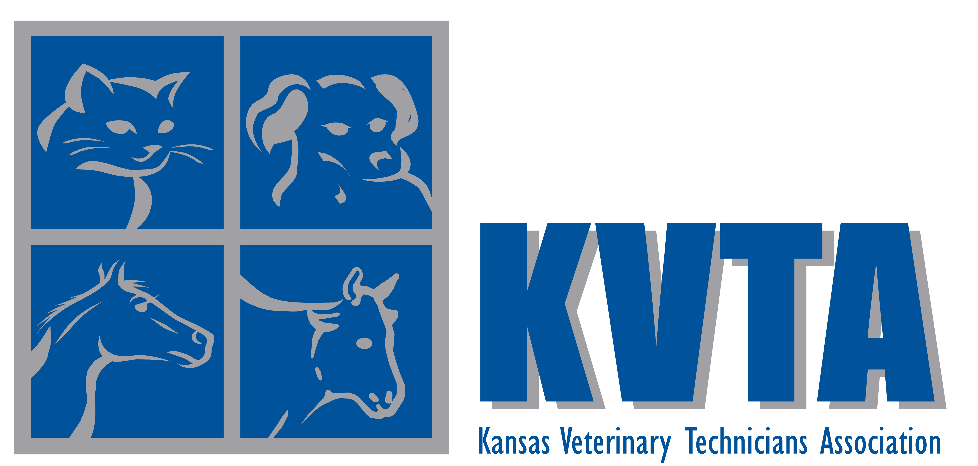

Volume No. IV Issue No. 1 Fall 2008

Executive Board
President:
Tammy Forshee, RVT, BS
2170 N. 60th Rd.
Jamestown, KS 66948
tgerlits@agmarkllc.com

2-Year Member at Large:
Karla Capper, RVT
13800 w. 135th St.
Olathe, KS 66062
vpprtjink@hotmail.com

1-Year Member at Large:
Wendy Baier, RVT
1722 N Main Apt. B
Rose Hill, KS 67133
wabvettech@yahoo.com

NAVTA Liaison:
Vickie Jones, RVT
2466 Road F
Americus, KS 66835

Secretary/Treasurer:
Cheryl Hermann, BA, RVT
22637 NW 2150 Rd.
Garnett, KS 66032
cahvettech@yahoo.com

Representative to the Registration Board
Kristen Webb, RVT
18649 262nd Road
Atchison, KS 66002
Pepper021@hotmail.com

Chairman of the Executive Board:
Jill Foster, BS, RVT
1315 Nottingham Circle
Wichita, KS 67204
jillkrvt@hotmail.com

President’s Message
By Tammy Forshee, RVT, BS

The 2008-year has been busy with numerous events by KVTA. We began the year with our ballots being mailed to Wamego for the election of 2008 officers. We added information to our web site and included links to many organizations. The KVTA Scholarship applications were mailed to Colby Community College and the winner was announced at the KVTA banquet in May! Way to go Carrie Jo!
In February we had a KVTA meeting for all members and officers in conjunction with the K-State Veterinary Technician’s Conference. KVTA also donated prizes to the general assembly at the conference! Our KVTA Booth was up as well with the updated pictures and fliers for all to see. The evening prior to this meeting the KVTA Officers got together and had a great meeting and supper in downtown Manhattan, KS.
Secretary Cheryl Hermann has done great getting out our newsletters to members during the year to help motivate and support KVTA as well as this great profession!
Dr. Randall Hobrock received the Veterinary Technician of the Year Award nominations this year and sent the chosen technician information to Cheryl and a plaque was ordered. We will be presenting the award at this individual’s clinic in honor of this great accomplishment!
KVTA worked in conjunction with NAVTA this summer to arrange a guest speaker for the Colby Community College CE and KVTA Annual Meeting on Oct 3rd, 2008. Denise will be speaking as part of the conference and KVTA is honored to have her representing our organization as well as NAVTA!!
A couple of our KVTA members were able to attend the CVC (Central Veterinary Conference) in Kansas City this summer and reported it was a super conference with many great technician CE classes and wet labs.
We checked into having our KVTA Booth at the Kansas State Fair this year, but they require us to have it set up and occupied for the entire 14 days. We did not have enough volunteers to accomplish this.
Cheryl kindly sent a letter to Governor Kathleen Sebelius to have National Veterinary Technician Week, in October, recognized in Kansas. The application was accepted and the Governor proclaimed the third week in October as Kansas Veterinary Technicians Week.
A KVTA meeting was held on September 7, in Kansas City and Officer Karla Capper arranged the speaker, Dr. Burnham, and yummy pizza. It was held in a very nice meeting room and the presentation on Animal Behavior in the Clinic Setting was well attended and enjoyed by those present. Thank you Karla for your efforts in supporting KVTA and helping us with continuing education!
KVTA is working on a sponsor so we can mail out a small appreciation gift to each one of you to arrive during National Veterinary Technicians Week!!
Currently officers are preparing for the nominations of new officers for 2009. We hope you are planning on being an officer, which is a great way support KVTA, and the Veterinary Technology Profession!

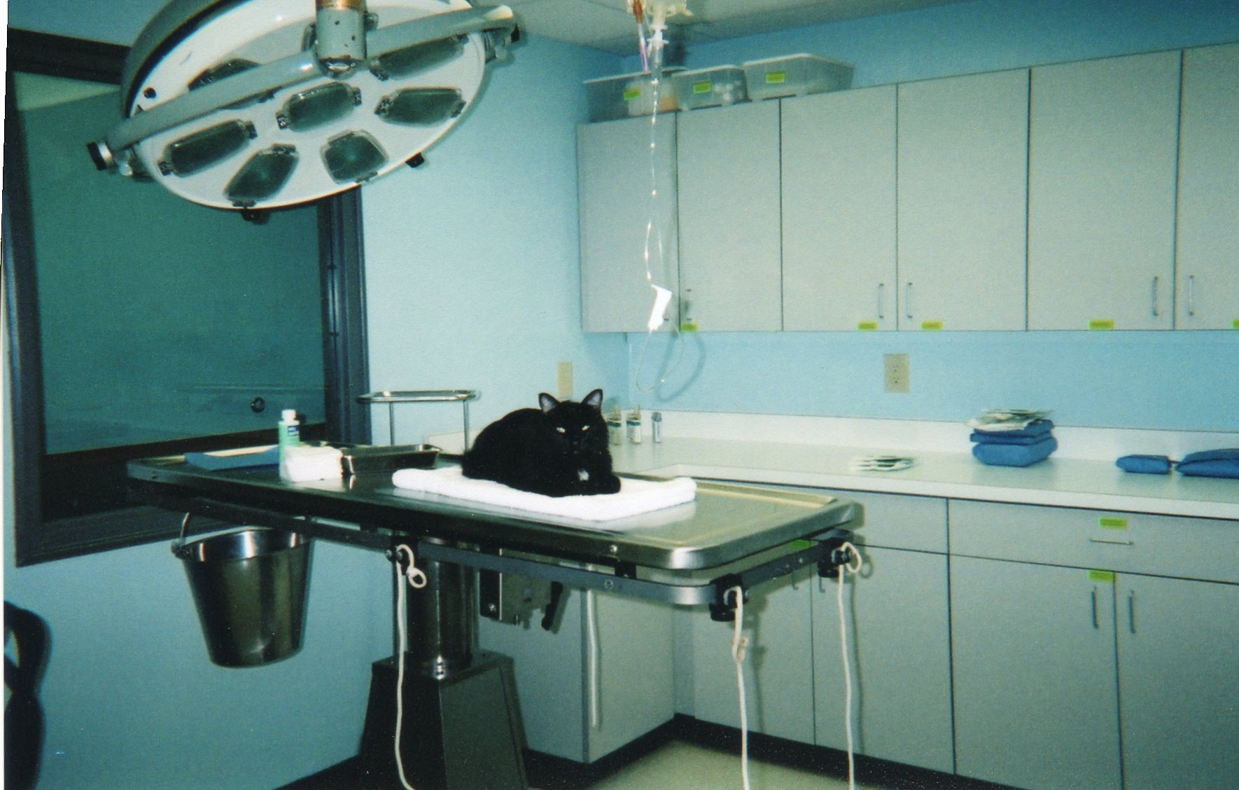
I think we’re going to need a little more anesthesia!

KVTA Meeting Minutes

September 7, 2008
Matt Ross Community Center
Overland Park, KS

President Tammy Forshee called the meeting to order at 12:00 pm. Officers present were Tammy Forshee, RVT, BS; Karla Capper, RVT; and Cheryl Hermann, BA, RVT.
Cheryl Hermann gave the Treasurer’s report of $1710.37.

Old Business:
SVTA – Tammy Forshee has been in contact with the SVTA at Colby Community College regarding a SVTA/KVTA Liaison, they have not chosen a member to be a representative to KVTA as of yet. Tammy has also been in contact with Dr. Martin about arranging for KVTA to sponsor an SVTA meeting prior to CE. There is also a link from the SVTA website to the KVTA website.
NAVTA Speaker – KVTA has arranged for a NAVTA speaker at the CE meeting in Colby. The speaker has been asked to discuss benefits of being an active member of the local veterinary technology association.
KVTA Scholarship –The KVTA scholarship was awarded to Carrie Jo Davidson at the SVTA banquet held in May. This information in on the KVTA website and will be published in the October issue of “Veterinary Technician”.
Vet Tech of the Year Award – The 2008 Veterinary Technician of the Year has been chosen. The Executive Board is in contact with the winner’s doctor to schedule a reception and presentation ceremony in her honor.
State Fair – KVTA was unable to have the booth at the Kansas State Fair since the fair board requires that a KVTA member be at the booth for the entire two weeks.
NVTW – KVTA will be sending out a gift to all members in celebration of National Veterinary Technicians Week. Cheryl Hermann sent a request to the governor to have Oct. 12-18 recognized as Kansas Veterinary Technician Week.
KCVMA – KVTA now has a link on the Kansas City Veterinary Medical Association Website. The latest newsletter is also available on their website.
Paraprofessional Committee – Cheryl Hermann has been appointed as the KVTA representative to the KVMA Paraprofessional Committee.

New Business:
KVTA would like to thank Karla for organizing the KVTA CE. Dr. Burcham gave a presentation on handling difficult patients in the exam room.
The Executive Board is brainstorming ways to increase membership.

With no further business to discuss, the meeting was adjourned at 12:30 pm.

KVTA Scholarship Winner

The Kansas Veterinary Technicians Association would like to announce that Carrie Jo Davidson has been selected as the 2008 KVTA Scholarship winner. Ms. Davidson, from Elkhart, Kansas, is enrolled in the Veterinary Technology Program at Colby Community College in Colby, Kansas where she currently carries a 4.0 GPA and will graduate in May 2009. As part of the application process, Ms. Davidson had to submit an essay outlining why she chose to become a Veterinary Technician and how she plans to better the profession. We had several very good applicants and the decision was a difficult one. We are excited that there will be soon be many intelligent, talented, and enthusiastic technicians joining the profession.
Congratulations Carrie Jo Davidson.

Jennifer Martin, DVM (left) Director of the Veterinary Technology Program at Colby Community College presents Carrie Jo Davidson (right) with the 2008 KVTA Scholarship.

Safety Tips
By Karla Capper, RVT

I am the Safety Manager at my clinic – oh, yeah, I know you all envy me and wish you had my job! But seriously, I am very concerned with safety and want my coworkers to be healthy and well. I just came from CVC with some new information that is good for all of us to know, so I would like to share it with you.
One thing that was mentioned several times is fire safety. Make sure your clinic has a good evacuation plan in case of fire, and revisit the plan often to reinforce the details in staff members’ minds. Have a central meeting place, not just “the parking lot” or “across the street” and make sure people know they should stay there until the supervisor releases them. It is very difficult for animal lovers to accept, but our first priority has to be human life. All employees should first evacuate to their designated meeting place, where the supervisor can then determine whether it is safe to return to evacuate animals. When the fire department comes, their first priority is to make sure all people are out of the building. If we are inside and difficult for them to find, their time is spent getting us out before they can try to get the animals out. We may inadvertently lose time that could be spent saving patients, if time is diverted saving us. Firefighters are equipped and ready to deal with the job of saving lives and putting out the fire. Our job is to be ready to triage the animals as they come out, so having a crash kit, which is easily accessible to take out of the building, is a great asset.
Personal safety is a growing concern, and veterinary clinics have a variety of times when this could be an issue. We do have money and drugs, occasionally someone comes in to take those from us. Don’t be a hero! Give them what they are asking for – insurance can replace monetary items. You should only fight back if they try to take you with them out of the building. If you have to work in the clinic alone, make sure someone knows where you are. If possible, drive all the way around the building before parking. Keep your cell phone and keys with you at all times, and keep the doors locked. When you go outside to get in your car, be alert and aware of your surroundings. Get into your vehicle and lock the doors. Do not unlock the door or roll down the window if someone approaches your vehicle, but tell them you will call 911 on your cell phone if necessary.
The number one thing we were told – remember to wash your hands! It sounds simple, but you know we all get in a hurry sometimes! Wash hands after handling each patient or using chemicals, especially before going to the bathroom or before eating.
Be safe – be healthy – be happy!

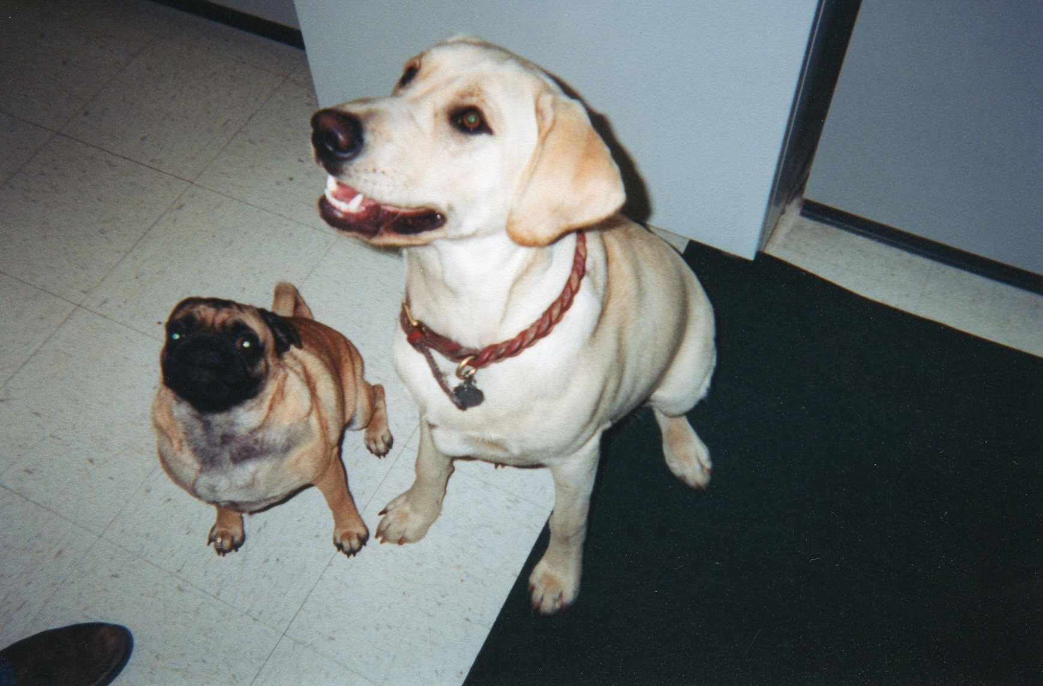
Treats? Did somebody say treats?

KVTA Continuing Education Meeting

By Karla Capper, RVT

KVTA hosted a lunch meeting Sunday, September 7, at the Matt Ross Community Center in Overland Park, KS. The speaker, Dr. J.C. Burcham, presented an interactive lecture on problem animals in the exam room. She stressed the importance of each visit to the clinic as a training exercise for the pet, be it a good experience or a bad one. As technicians, we are advocates for pets, we should try to make those experiences positive, so the animal will enjoy (or at least tolerate) their trip to the veterinarian. Several methods of dealing with angry or fearful pets were discussed, including minimal restraint, the use of towels, and chemical restraint when necessary. The goal is to make the patient as comfortable as possible so we can proceed with treatments without causing undue stress to the pet. Client education is very important. Owners can start “puppy massage” or “kitten massage” when young training their pet to tolerate handling of the feet, ears and body making it a rewarding time for them. This will benefit us in our job if done correctly! Dr. Burcham also gave some tips on desensitizing pets who are fearful of nail trims, making the task less traumatic to both pets and us.
Several door prizes, including a KVTA mug, a Wonder Walker, and cat toys were given out after the meeting. Don’t miss out next time, you could learn some new tips and techniques, network with peers, enjoy a pizza and maybe come home with a prize!

Kansas Veterinary Technician of the Year

Congratulations to Jan Hueben, RVT, who was chosen as the 2008 Kansas Veterinary Technician of the Year.
Jan graduated from Maple Woods Community College with an AAS in Veterinary Technology in 1992. She has been employed at Trailridge Pet Hospital in Shawnee, KS, for 19 years. She is active in both NAVTA and KVTA. Dan E. Cram, DVM, and Cheryl Ruch, a client at Trailridge Pet Hospital, nominated Jan for this honor.
According to Dr. Cram, Jan is “extremely proficient technically. She has a never-ending desire to learn and improve through continuing education classes, reading, and on-line research. Her finest quality, however, is her genuine compassion for both animals and people. I like to think I have the same qualities but admit I suffer from typical male impatience at times. Jan helps keep me focused on what is really important in a veterinary practice. She has helped make me not only a better veterinarian, but also a better person.”
Cheryl Ruch adds “She seems to possess that rare blend of technical expertise and people skills. I know her medical skills are above reproach and her days are very full assisting Dr. Cram with surgeries, cleaning teeth, and doing work in the lab. Yet she still finds the time to greet us and put us at ease as she talks with us in the exam room. Jan has excellent rapport with each animal. She knows each and every pet by name and treats them as she would her own pet. She is never too busy to rub and ear or scratch a tummy.”
Cheryl Hermann, KVTA Secretary/Treasurer on October 8, 2008, presented Jan with her plaque. Dr. Dram, Ms. Ruch, Bitty, and several coworkers were in attendance. Jan received a delicious cake, beautiful flowers, and several Starbucks gift cards from her coworkers.
Thanks to Dr. Dram and Ms. Ruch for taking time from their busy schedules to nominate such a deserving technician.

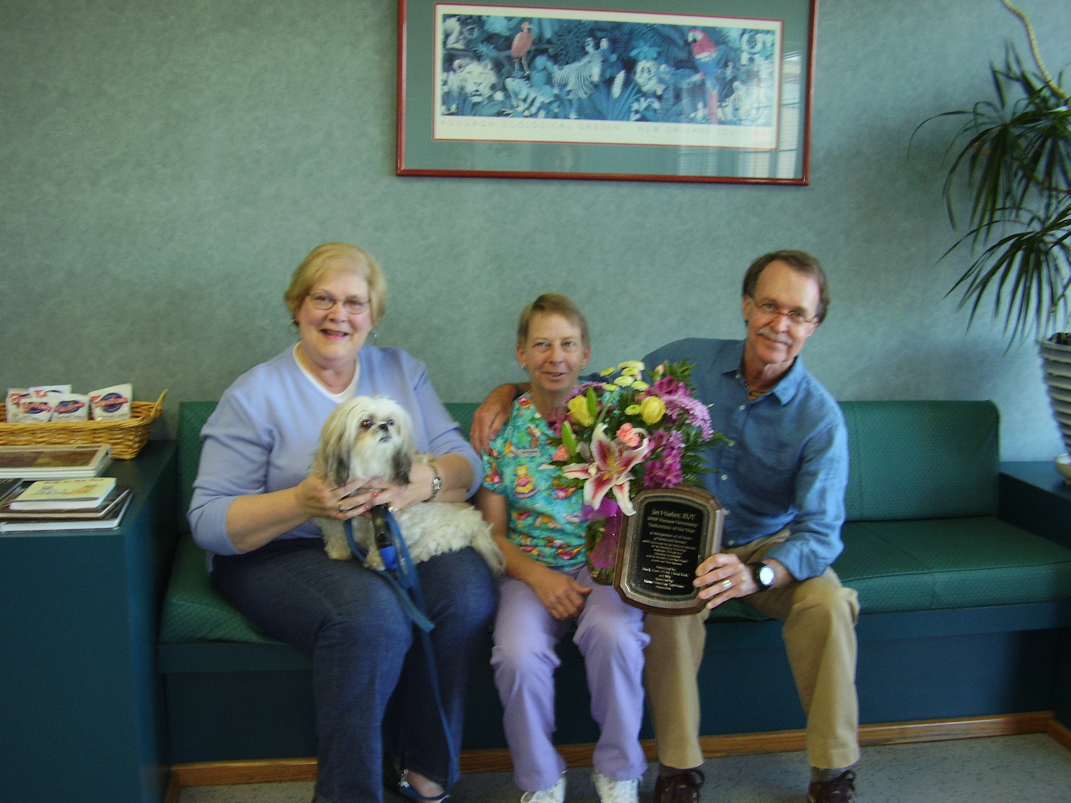
Cheryl Ruch, Bitty, Jan Hueben, and Dr. Dan E. Cram

Kansas Veterinary Technicians Week

In celebration of National Veterinary Technicians Week, KVTA petitioned Governor Sebelius for a proclamation making the third week in October 2008, Kansas Veterinary Technicians Week.

State of Kansas
Proclamation
by the
Governor

TO THE PROPLE OF KANSAS, GREETINGS:

WHEREAS, veterinary technicians are important members of the veterinary health care team, work in veterinary medicine throughout the state, and are extremely important in the effort to provide quality animal health care to insure the humane treatment of all animals; and

WHEREAS, there are over sixty accredited programs throughout the United States which provide intensive study of the skills and knowledge to work competently as a Veterinary Technicians, including anatomy, physiology, microbiology, clinical techniques, pharmacology, anesthesiology, surgical and medical nursing, radiology, and clinical pathology training; and

WHEREAS, it is extremely important that each veterinary technicians maintain registration through the successful completion of a national and state examination, practice lifelong learning through continuing education and uphold high ethical standards; and

WHEREAS, veterinary technicians will be joining their colleagues across the sate to urge all to become aware of the important contributions or veterinary technicians to the health and well being of all animals;

THEREFORE, I, KATHLEEN SEBELIUS, GOVERNOR OF THE STATE OF KANSAS do hereby proclaim the third week in October 2008 as
KANSAS VETERINARY TECHNICIANS WEEK
in Kansas.

DONE: At the Capitol in Topeka
Under the Great Seal of the
State this 19th day of
September, A.D. 2008

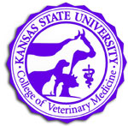

Need a few continuing education hours?

Don’t have time to travel to CE meetings?

Try K-State’s Award-Winning VetBytes Seminar Series!

VetBytes offers convenient continuing education on YOUR schedule!

Participate in individual seminars, or complete one or two certificate of completion programs (an receive a price break!). For a list of VetBytes seminars and more information go to:

www.vet.k-state.edu/CE/vetbytes247.htm

Certificate programs include:
Bull Evaluation & Management
Small Animal Medicine Updates

Contact Marci Ritter or Linda Johnson at VMCE@vet.k-state.edu
or (785)532-5696 if you need more information.

